JINU CHARLES P
Creative Director
Art Director

As a Creative enthusiast, the past 9 years endowed me more sophisticated expertise as a Creative Director & Art Director. From my experience I do believe that the clients, the audience & the design combine perfectly to create a relationship between the user & the brand. As an Creative Director, I enjoy inﬂuencing that relationship with my strong vision, aesthetic clarity & understanding of marketing principles.

https://www.behance.net/jcharles
Mail: j.charles.inﬁnite@gmail.com
Call: +91 8089590578
Whatsapp: +91 8089590578

Charles Villa, Peringala, Ernakulam

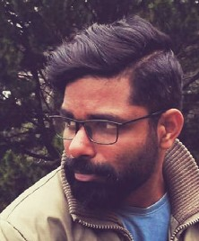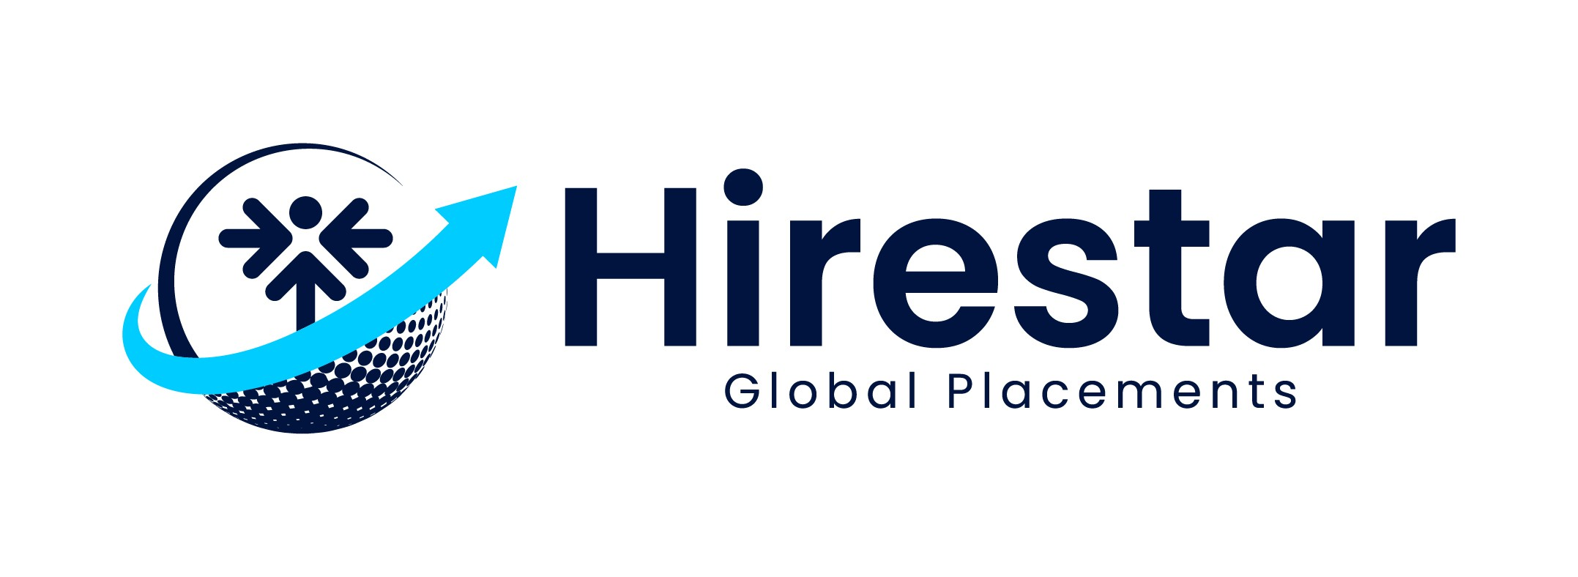Software Skills Languages
Adobe Illustrator English

Adobe Photoshop Malayalam

Adobe Indesign Tamil Procreate
After Effects

Education

PG in Visual Effects 2009-2011: ICAT, Chennai
BA Functional English

2005-2008: Malabar Christian College Calicut

Plus Two

2004-2005: Malabar Christian College Calicut

SSLC
2002-2003: GVHSS Cheruvannur, Calicut

Hobbies & Interests
Experience

Netventure: 2023

Creative Director
Face of a company's creative, advertising & marketing efforts.
Inspire & guide the vision of the design team, oversee the work of
creative team & others. Reviewing & approving presentations & deliverables. Developing ideas for advertising or promotional campaigns.

D3 Teck, Kochi: 2022-2023

Art Director
Inspire & guide the vision of the design team, oversee the work of illustrators, graphic/visual designers, photographers, & others who are engaged in artwork. Responsible for creating compelling visuals that speak directly to the audience.

Multiply Marketing Consultancy, Abu Dhabi: 2021-2021

Art Director
Responsible to promote client & their business in social media platforms. Developing creative ideas & concepts.

Adventz Advertising Agency, Muscat: 2020-2021

Graphic Designer & Illustrator
Listening to clients & understanding their needs before making
design decisions. Responsible for developing ideas, designs & illustrations.

Whyte Creations, Kochi: 2018-2020

Art Director
Responsible for creating design solutions that have a high visual impact. Developing creative ideas & concepts.

Zhooyi Communications, Kochi: 2015-2018

Graphic Designer & Illustrator
Responsible for creating designs & ideas, choosing the appropriate media & style to meet the client's objectives.

Yara Communications: 2013-2015

Brand Designer & Illustrator
Responsible for creating logos, Brand books & marketing materials choosing the appropriate media & style to meet the client's objectives.

